Deep Skilling Week 7 Assignment

- ReactJS-HOL
Code:
ListofPlayers.js

import React from "react";
const ListofPlayers = () => {
const players = [
{ name: "Virat", score: 90 },
{ name: "Rohit", score: 85 },
{ name: "Rahul", score: 45 },
{ name: "Shreyas", score: 32 },
{ name: "Surya", score: 100 },
{ name: "Pant", score: 75 },
{ name: "Jadeja", score: 66 },
{ name: "Ashwin", score: 40 },
{ name: "Shami", score: 20 },
{ name: "Bumrah", score: 70 },
{ name: "Kuldeep", score: 55 }
];

const below70 = players.filter(player => player.score < 70);

return (
<div>
<h2>All Players:</h2>
<ul>
{players.map((player, idx) => (
<li key={idx}>{player.name} - {player.score}</li>
))}
</ul>

<h3>Players with score below 70:</h3>
<ul>
{below70.map((player, idx) => (
<li key={idx}>{player.name} - {player.score}</li>
))}
</ul>
</div>
);
};

export default ListofPlayers;
IndianPlayers.js

import React from "react";
const IndianPlayers = () => {
const oddTeam = ["Virat", "Rahul", "Pant", "Ashwin", "Kuldeep"];
const evenTeam = ["Rohit", "Surya", "Jadeja", "Shami", "Bumrah", "Shreyas"];

// Destructuring example
const [odd1, odd2, ...restOdd] = oddTeam;
const [even1, even2, ...restEven] = evenTeam;

// Merge arrays using spread
const T20players = ["Hardik", "Bhuvi"];
const RanjiPlayers = ["Sarfaraz", "Prithvi"];
const allPlayers = [...T20players, ...RanjiPlayers];

return (
<div>
<h2>Odd Team:</h2>
<ul>
<li>{odd1}</li>
<li>{odd2}</li>
{restOdd.map((p, i) => <li key={i}>{p}</li>)}
</ul>

<h2>Even Team:</h2>
<ul>
<li>{even1}</li>
<li>{even2}</li>
{restEven.map((p, i) => <li key={i}>{p}</li>)}
</ul>

<h2>All Combined Players (T20 + Ranji):</h2>
<ul>
{allPlayers.map((p, i) => <li key={i}>{p}</li>)}
</ul>
</div>
);
};
export default IndianPlayers;

App.js

import React from "react";
import ListofPlayers from "./components/ListofPlayers";
import IndianPlayers from "./components/IndianPlayers";

function App() {
const flag = false;

return (
<div className="App">
<h1>🏏 Cricket App</h1>
{flag ? <ListofPlayers /> : <IndianPlayers />}
</div>
);
}

export default App;

OUTPUT:
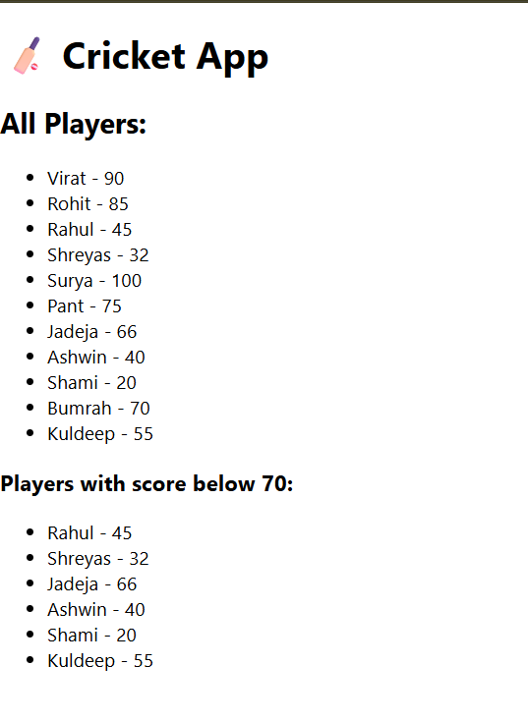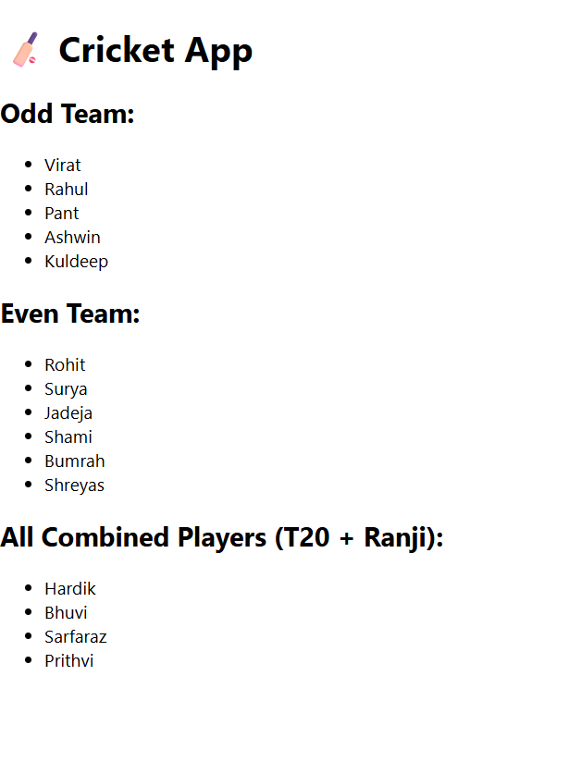

- ReactJS-HOL
Code:
App.js
import React from 'react';
import './App.css'; // Optional: for custom CSS

function App() {
// Object representing one office
const office = {
name: "DreamSpace Office",
rent: 55000,
address: "Sector 5, Salt Lake, Kolkata"
};

// List of office objects
const officeList = [
{ name: "TechPark Hub", rent: 75000, address: "Bangalore" },
{ name: "WorkNest", rent: 58000, address: "Hyderabad" },
{ name: "GrowMore Office", rent: 60000, address: "Mumbai" },
{ name: "InnovateLab", rent: 45000, address: "Pune" },
];

// Function to apply dynamic color to rent
const getRentStyle = (rent) => ({
color: rent < 60000 ? "red" : "green",
fontWeight: "bold"
});

return (
<div style={{ padding: '20px', fontFamily: 'Arial' }}>
<h1>🏢 Office Space Rental Portal</h1>

<img
src="https://images.unsplash.com/photo-1599331248596- 5c730b61c59a"
alt="Office Space"
style={{ width: '400px', height: '250px', borderRadius: '8px' }}
/>

<h2>Main Office:</h2>
<p>Name: {office.name}</p>
<p style={getRentStyle(office.rent)}>Rent: ₹{office.rent}</p>
<p>Address: {office.address}</p>

<h2>Available Office Listings:</h2>
{officeList.map((item, index) => (
<div key={index} style={{ marginBottom: '15px' }}>
<p><strong>Name:</strong> {item.name}</p>
<p style={getRentStyle(item.rent)}><strong>Rent:</strong> ₹{item.rent}</p>
<p><strong>Address:</strong> {item.address}</p>
<hr />
</div>
))}
</div>
);
}

export default App;

OUTPUT:

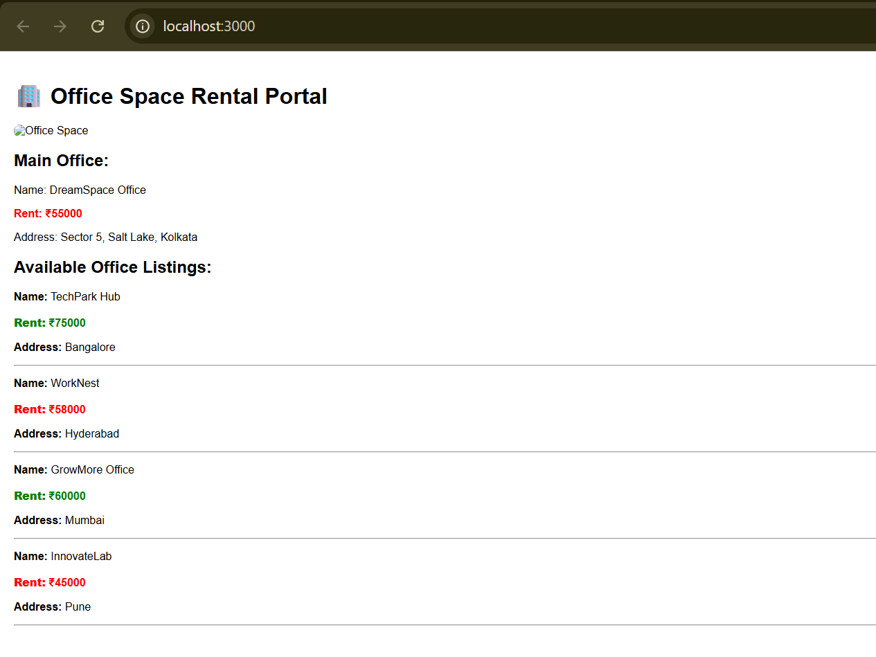

- ReactJS-HOL
Code:
Counter.js
import React, { Component } from 'react';
class Counter extends Component {
constructor(props) {
super(props);
this.state = {
count: 0
};
// Binding method
this.handleWelcome = this.handleWelcome.bind(this);
}

increment = () => {
this.setState(prev => ({ count: prev.count + 1 }));
this.sayHello();
};

sayHello = () => {
console.log("Hello! This is the increment button.");
};

decrement = () => {
this.setState(prev => ({ count: prev.count - 1 }));
};

handleWelcome(message) {
alert(message);
}

handleSyntheticEvent = (e) => {
console.log("Synthetic Event: ", e);
alert("I was clicked");
};

render() {
return (
<div style={{ padding: '20px', border: '1px solid #ccc' }}>
<h2>Counter Example</h2>
<p>Count: {this.state.count}</p>
<button onClick={this.increment}>Increment</button>
<button onClick={this.decrement} style={{ marginLeft: '10px' }}>Decrement</button>

<div style={{ marginTop: '20px' }}>
<button onClick={() => this.handleWelcome("Welcome to Event Handling in React")}>
Say Welcome
</button>
</div>

<div style={{ marginTop: '20px' }}>
<button onClick={this.handleSyntheticEvent}>
OnPress
</button>
</div>
</div>
);
}
}

export default Counter;

CurrencyConvertor.js
import React, { useState } from 'react';
function CurrencyConvertor() {
const [rupees, setRupees] = useState('');
const [euros, setEuros] = useState(null);

const handleSubmit = (e) => {
e.preventDefault(); // SyntheticEvent
const conversionRate = 0.011; // Example: 1 INR = 0.011 EUR
setEuros((parseFloat(rupees) * conversionRate).toFixed(2));
};

return (
<div style={{ padding: '20px', border: '1px solid #ccc', marginTop: '20px' }}>
<h2>Currency Convertor</h2>
<form onSubmit={handleSubmit}>
<label>
Amount in INR:
<input
type="number"
value={rupees}
onChange={(e) => setRupees(e.target.value)}
style={{ marginLeft: '10px' }}
/>
</label>
<button type="submit" style={{ marginLeft: '10px' }}>Convert</button>
</form>

{euros !== null && (
<p style={{ marginTop: '10px' }}>
€ {euros} EUR
</p>
)}
</div>
);
}

export default CurrencyConvertor;

App.js
import React from 'react';
import Counter from './components/Counter';
import CurrencyConvertor from './components/CurrencyConvertor';

function App() {
return (
<div className="App" style={{ margin: '40px' }}>
<h1>🎯 React Event Handling Examples</h1>
<Counter />
<CurrencyConvertor />
</div>
);
}

export default App;

OUTPUT:

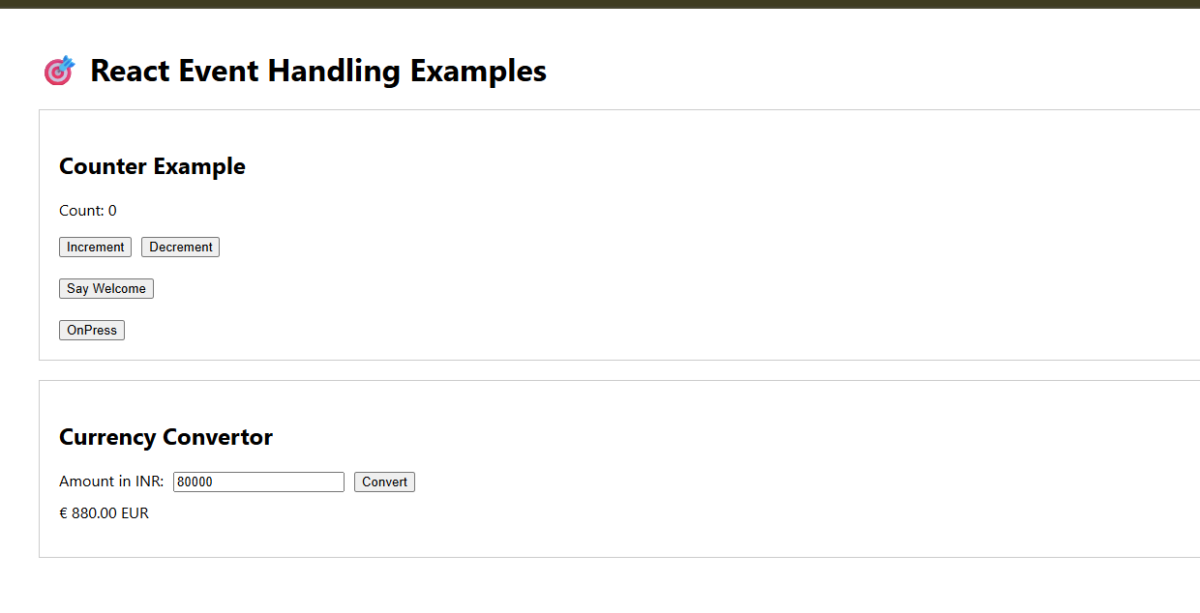
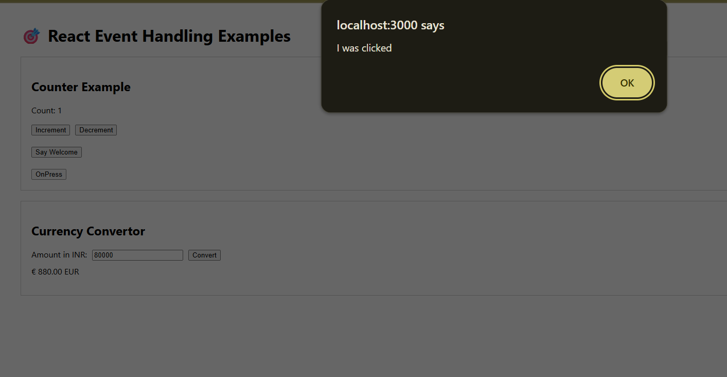
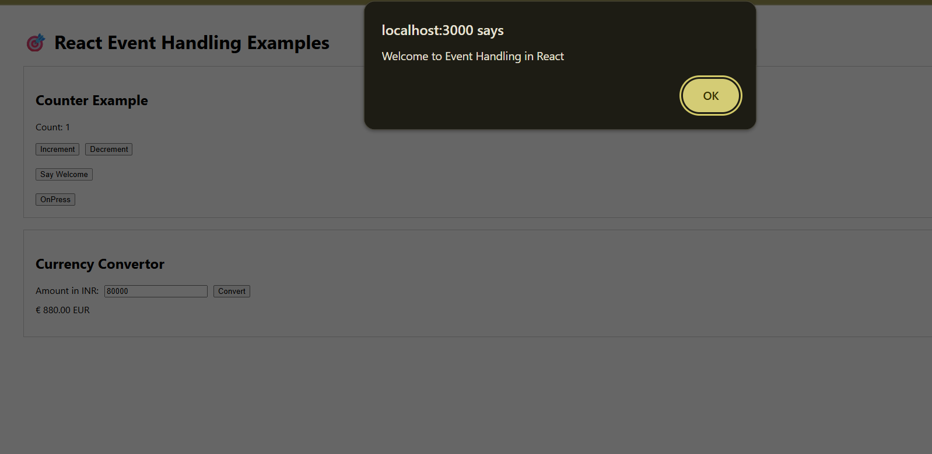

- ReactJS-HOL
Code:
GuestPage.js

import React from 'react';
const GuestPage = () => {
return (
<div style={{ padding: '20px' }}>
<h2>✈️ Welcome Guest</h2>
<p>Here are some flights you can view:</p>
<ul>
<li>Flight A123 - Delhi to Mumbai</li>
<li>Flight B456 - Kolkata to Bangalore</li>
<li>Flight C789 - Chennai to Goa</li>
</ul>
<p><i>Login to book tickets.</i></p>
</div>
);
};
export default GuestPage;

UserPage.js
import React from 'react';
const UserPage = () => {
return (
<div style={{ padding: '20px' }}>
<h2>👤 Welcome User</h2>
<p>You are logged in and can book flights:</p>
<ul>
<li>Flight A123 - <button>Book</button></li>
<li>Flight B456 - <button>Book</button></li>
<li>Flight C789 - <button>Book</button></li>
</ul>
</div>
);
};

export default UserPage;

App.js
import React, { useState } from 'react';
import GuestPage from './components/GuestPage';
import UserPage from './components/UserPage';

function App() {
const [isLoggedIn, setIsLoggedIn] = useState(false);

// Element variable
let content;
if (isLoggedIn) {
content = <UserPage />;
} else {
content = <GuestPage />;
}

return (
<div className="App" style={{ padding: '30px', fontFamily: 'Arial' }}>
<h1>🛫 Ticket Booking App</h1>
<div style={{ marginBottom: '20px' }}>
{isLoggedIn ? (
<button onClick={() => setIsLoggedIn(false)}>Logout</button>
) : (
<button onClick={() => setIsLoggedIn(true)}>Login</button>
)}
</div>
{content}
</div>
);
}

export default App;

OUTPUT:
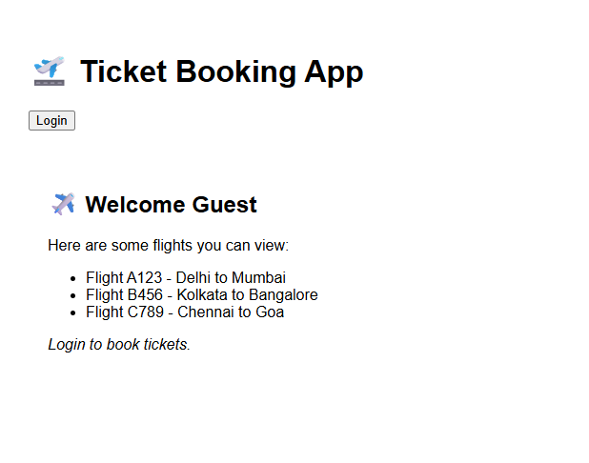
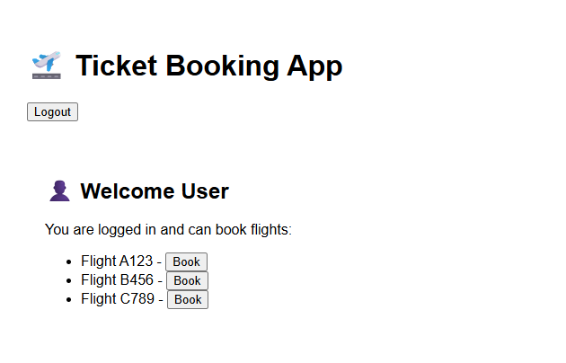
- ReactJS-HOL
Code:
BookDetails.js

import React from 'react';
const books = [
{ id: 1, title: "React for Beginners", author: "John Doe" },
{ id: 2, title: "Advanced React", author: "Jane Smith" },
{ id: 3, title: "React Hooks in Depth", author: "Alex Johnson" }
];

const BookDetails = () => {
return (
<div>
<h2>📚 Book Details</h2>
<ul>
{books.map(book => (
<li key={book.id}>
<strong>{book.title}</strong> by {book.author}
</li>
))}
</ul>
</div>
);
};

export default BookDetails;

BlogDetails.js
import React from 'react';
const BlogDetails = () => {
return (
<div>
<h2>📝 Blog Details</h2>
<p>Welcome to our latest blog on React development and best practices!</p>
</div>
);
};

export default BlogDetails;

CourseDetails.js
import React from 'react';
const courses = [
{ id: 1, name: "React Bootcamp", duration: "4 Weeks" },
{ id: 2, name: "JS Mastery", duration: "6 Weeks" }
];

const CourseDetails = () => {
return (
<div>
<h2>🎓 Course Details</h2>
<ul>
{courses.map(course => (
<li key={course.id}>
{course.name} - {course.duration}
</li>
))}
</ul>
</div>
);
};
export default CourseDetails;

App.js
import React, { useState } from 'react';
import BookDetails from './components/BookDetails';
import BlogDetails from './components/BlogDetails';
import CourseDetails from './components/CourseDetails';

function App() {
const [view, setView] = useState("book");

// Element variable approach
let componentToShow;
if (view === "book") {
componentToShow = <BookDetails />;
} else if (view === "blog") {
componentToShow = <BlogDetails />;
} else {
componentToShow = <CourseDetails />;
}

return (
<div style={{ padding: '20px', fontFamily: 'Arial' }}>
<h1>🧑‍💻 Blogger App</h1>
<div style={{ marginBottom: '20px' }}>
<button onClick={() => setView("book")}>Show Books</button>
<button onClick={() => setView("blog")} style={{ marginLeft:
'10px' }}>Show Blogs</button>
<button onClick={() => setView("course")} style={{ marginLeft:
'10px' }}>Show Courses</button>
</div>

{/* Element variable rendering */}
{componentToShow}

{/* Logical AND rendering */}
{view === "book" && <p>You're viewing Book details.</p>}

{/* Ternary rendering for footer */}
<footer style={{ marginTop: '40px' }}>
<p>
{view === "course"
? "Courses are open for enrollment!"
: "Browse our content to learn more!"}
</p>
</footer>
</div>
);
}
export default App;

OUTPUT:

